Fully Automatic Rewinding Machine Model ZRF-1300
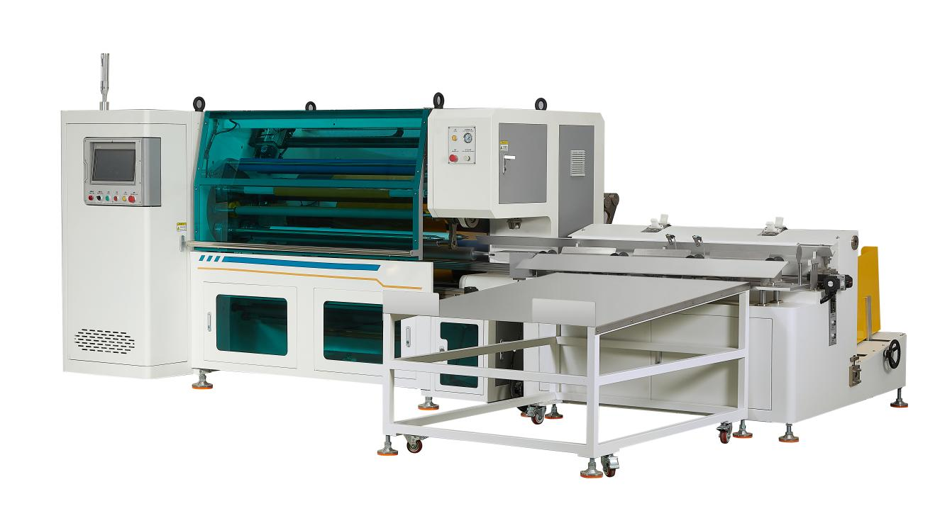
Equipment layout：
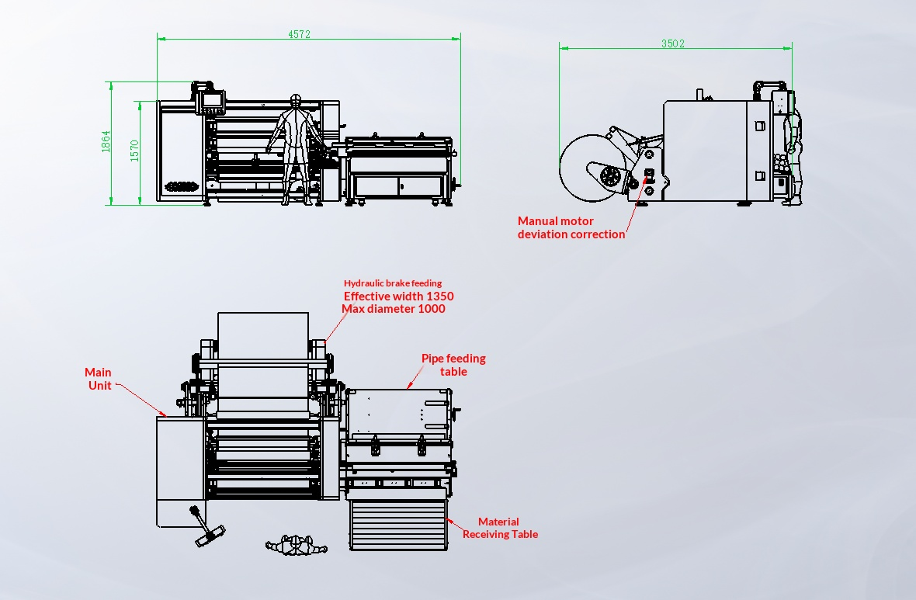
Basic Use：
It is mainly used for kraft paper, paper tape, medical tape and wire harness tape (dual power traction).

Product characteristics：
- Hechuan motion control system, servo control roll, servo control active traction, servo control label flipping, servo control pull, servo control conversion shaft, servo control discharge, servo control roll roller, servo control cutting knife, servo control waste, servo control into the paper tube.
- High precision classifier transmission positioning structure, 4-axis automatic exchange, to achieve non-stop production, improve production efficiency.
- Automatic smoothing rods are added at winding and finishing points to ensure quick sealing without wrinkles.
- Servo automatically shift the press roll to ensure the size of the gap between the press roll and the reel, so that the winding is more smooth.
- Using the hydraulic system for automatic feeding, convenient, fast and labor-saving.
- With material platform, convenient material, reduce material waste.
- The servo module is pulled, labeled, and the length and position can be adjusted at will, with convenient adjustment and accurate position.
- Mobile discharge table, can store 100 rolls of finished products, can be dragged at will, convenient for follow-up processing.
- Automatic loading tube, servo threading tube, automatic labeling, automatic cutting, automatic finishing, automatic discharge
- automatic tension release, stable tension, flat fit, stable start and stop. Edge control, winding flat.
- Servo motor drawing, length calculation is accurate. Servo motor torque winding, winding tension is stable, accurate, winding exquisite work, flat end face
- can be rewound with rubber surface or stripped back paper. rewind with adhesive surface or peel off the base paper
- Using air expansion shaft, convenient loading and unloading material, fast, using hydraulic cylinder lifting, automatic correction, roll magnetic powder brake roll diameter type automatic tension control, accurate control of torque.
- Tungsten steel round knife is used to cut the material, which is durable and neat.
- No film alarm, cut off alarm, no paper tube alarm stop.
- Using hcfa motion control system, one key start, easy to replace specifications.
- There are two film walking methods, which can be divided into (① Paper tape,masking tape, etc.) and (② acrylic tape).

Main technical parameters：
Model | STF-1300
paper core | 25.4/38/50/76（CUSTOMIZABLE）
Unwinding master roll | 1000mm(MAX)
Rewinding diameter | 30-140mm
Rewind width | W（700-1350）mm
Production speed | 200m/min  4-5pcs/min（15m）(subject to rewinding process）
power supply | 380V 50/60HZ/15KW
air pressure | 5KG
Machine size | 3502*4572*1864mm
Net Weight | 2000KG

Configuration parameters：
Model | STF-1300
Touch screen | 14-inch MCGS HMI
Rack wall board | 36mm
Motion controller | HCFA
Active traction servo motor | HCFA
Active traction servo driver | HCFA
Label flip servo motor | HCFA
Label flip driver | HCFA
Pull-out servo motor | HCFA
Tag driver | HCFA
Discharge servo motor | HCFA
Discharge driver | HCFA
Coiling press roller servo motor | HCFA
Winding press roll driver | HCFA
Cutter servo motor | HCFA
Cutter driver | HCFA
Winding Servo Motor | HCFA
Winding Servo Drive | HCFA
Pipe threading servo motor | HCFA
Pipe threading servo driver | HCFA
Four-axis flip divider | JUJIU
motor | MAILI
Cutter motor | MAILI
reducer | SMETRE
magnetic powder brake | WREZUN
Air switch | CHINT
switching power supply | MINGWEI
Stepper Motor Power Supply | MINGWEI
Edge correction power supply | MINGWEI
Linear Guide | KNK
Photoelectric Sensor | BOJKE
Material detection sensor | BOJKE
Proximity Switch | Yangming
Contactor | SCHNEIDER
Relay | IDEA
Button Switch | SCHNEIDER
Tri-color warning light | TAYB
Solenoid valve | ASICKO
Cylinder | AIRTAC
Linear Slide | HIWIN
Magnetic Switch | AIRTAC
Unwinding, waste collection 3 inch gas expansion shaft | TAIWAN CHINA
Bearing | NSK
Traction Shaft | Nano coating for anti-sticking
Compression Roll | Package of silica gel
Transition Roller | Nano coating for anti-sticking
Scalpel | 100MM tungsten steel round knife

